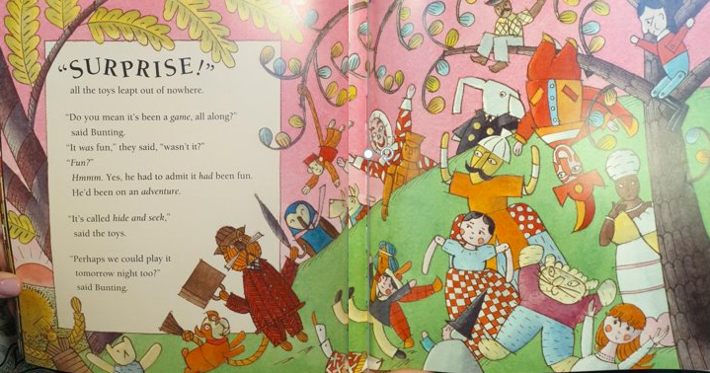
Noun (toy) | Adjective (describe) | Verb (action)
Punch | Jolly crazy silly | hanging upside down
Handsome Harry | Friendly joyful | Cheering loudly
Banger the dog | happy excited | Barking and leaping
Mr Jolly Boy | Funny, red jumper | Sitting in the tree
Woolworth | kind , pink tie | Peeking over the hill
Winnie | Cute, fluffy | Waving her arms
Pip | Curly tail, red waistcoat, cheeky | Swinging from the tree

