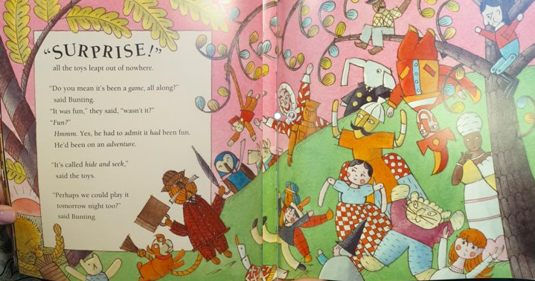
Noun (toy) | Adjective (describe) | Verb (action)

