1. 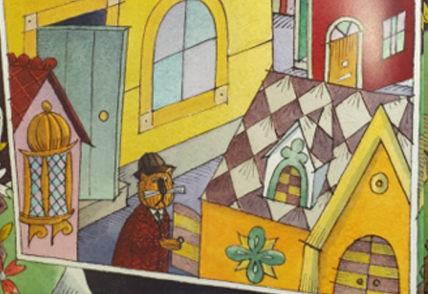 2. 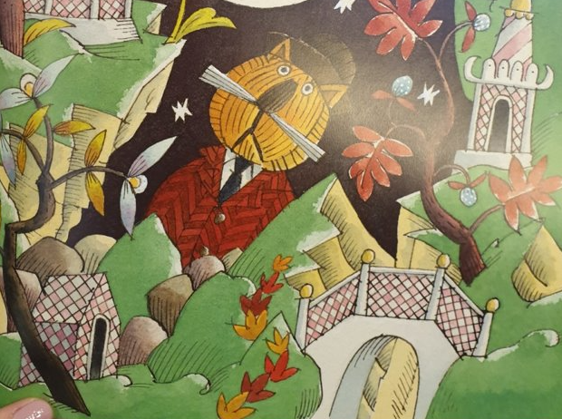 3. 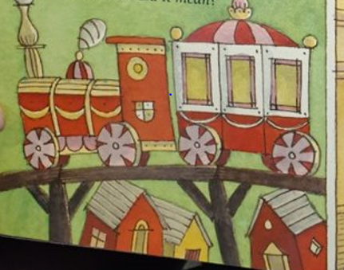

Task: Write a sentence for each of these pictures in order to say where Bunting hunted for the toys when they ran away. Start each sentence with a different time connective. Choose carefully e.g. Firstly can only go by the first picture. Add as much detail to retell the story as you can e.g. After that Bunting searched in the beautiful Chinese garden, but they weren’t there!

Try to vary the verb you use too e.g. searched, looked, hunted, checked.

Here are some examples of time connectives you could use:

Firstly Then Next Once Before

After that Last of all Finally Following

4. 5. 